**Pump Station Status:**

**Survival Analysis**

Survival Analysis

Dr. Matthew Austin

Orange Team 2

Qing Feng, Andrew Moolenaar, Carlos Chávez, Julie Huang, Bill Jenista

**Executive Summary**

The goal of our team is to conduct a survival analysis for the pump stations in the Gulf Coast area. Through our analysis of the survivability of pumps during Hurricane Katrina, we found that the median survival time was 45 hours, and the survival probability of the 770 pumps analyzed was 41%. Additionally, disaggregating the survival curves concluded that no single cause dominated the pump failures and the survival curves are statistically different from each other.

Furthermore, we found that the hazard rate increased significantly at two times during the storm: about the 25-hour and 45-hour marks. We hypothesize that events occurred at these times that led to the increased risk of jamming and surge-related failures respectively. The risk of mechanical failure significantly increased at about the 45-hour mark as well. We recommend the Center for Risk Management investigate any additional data to identify these events as they are likely related to a large portion of the pump failures and should be protected against if reasonable.

**Analysis & Results**

The dataset provided by the Steering Committee of the Center for Risk Management contains information from 770 pump stations on the Gulf Coast. About 41% of the pump stations survived the critical 48-hour storm period; the major reasons for non-survival were flooding (flood), mechanical failure (motor), water surges (surge), and intake jamming (jammed). Overall, the median survival time was 45 hours, meaning 50% of the pump stations survived beyond 45 hours. Table 1 below gives a further breakdown of failures by reason. Although the total failures caused by each reason are similar, the median survival times are not. A closer examination revealed two groupings by median survival time: 1) Intake jamming and flooding, 2) water surges and mechanical failures.

|  |  |  |  |
| --- | --- | --- | --- |
| **Reason for Failure** | **Number of Failures** | **Failure**  **Rate** | **Median Survival Time** |
| Jammed | 116 | 15.06% | 25 |
| Flood | 115 | 14.94% | 26 |
| Surge | 111 | 14.42% | 42 |
| Motor | 112 | 14.55% | 45 |

Table 1. Summary Statistics by Reason

The overall survival curve below (Figure 1) shows that the pumps fail at a steady rate except for two time periods during which a large number of pumps fail rapidly. To further investigate this, we stratified the survival curve by the cause of failure.

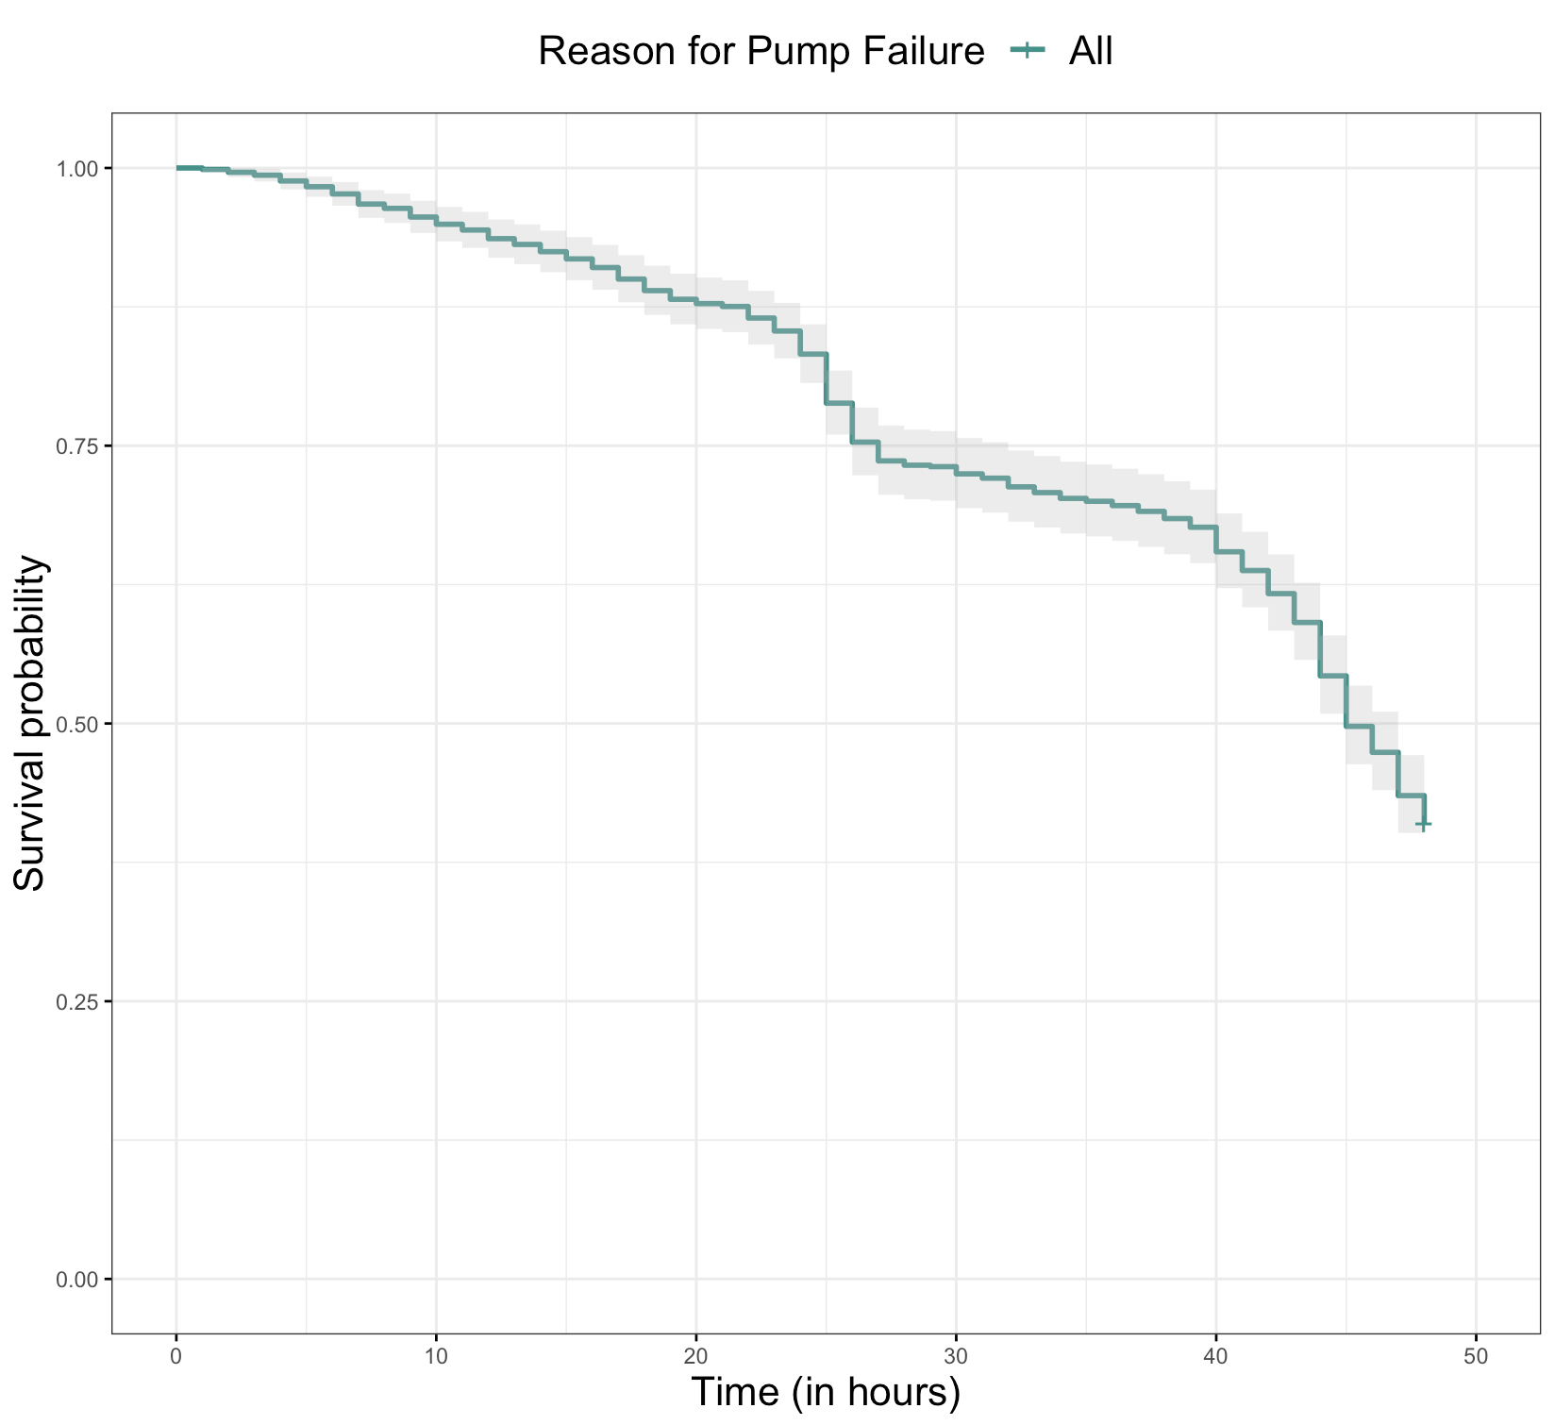

Figure 1. Overall Pump Survival Curve

As can be seen in Figure 2, we can visualize the survival probability during each hour for each reason. Motor (orange) and surge (green) failures both follow a similar pattern. These pumps were working during the first day of the storm and well into the second day; after around 40 hours, though, a large number of failures occurred. We hypothesize there may have been a major storm surge at this hour mark where these pumps are located, causing this breakdown. For the pumps that failed mechanically, they may have reached an operating limit due to continuous operation in the storm conditions. Flooding failure (yellow) seems to have a steady, linear decrease throughout the entire duration of the storm. This may indicate that flooding failures occur randomly at a rate independent of storm duration. Jamming failure caused by trash (red) occur steadily until a steep drop off at around 24 hours. While many of the pumps may be able to take on water for longer periods of time, it appears that they can not handle the intake of trash or landslide materials for as long a time. This quick drop in the curve indicates that there may have been an event due to the storm in which a large amount of debris was released during this time causing these pumps to jam. This single, hypothesized event could also be why we do not see many jams after this hour mark, and we recommend further investigation into this phenomenon.

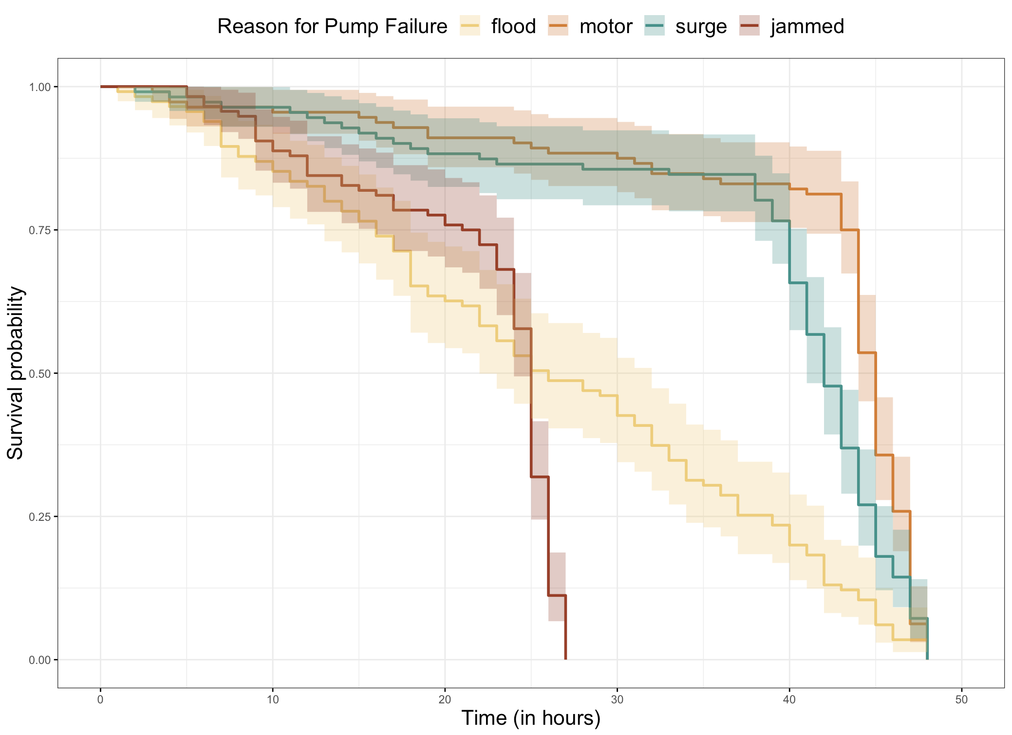

Figure 2. Pump Survival Curves Stratified by Failure Reason

Based on Figure 2, the only reasons that appear to have similar curves are motor and surge, in which each drop off around 40 hours. Based on the Chi-squared values of the log-rank test, we found that this is not the case. None of our curves are similar to each other. Using the adjusted p-value from Tukey-Kramer, we found that all of the curves are statistically different at the 95% confidence level. With this knowledge, we recommend not binning any of the failures together, since they are all statistically different.

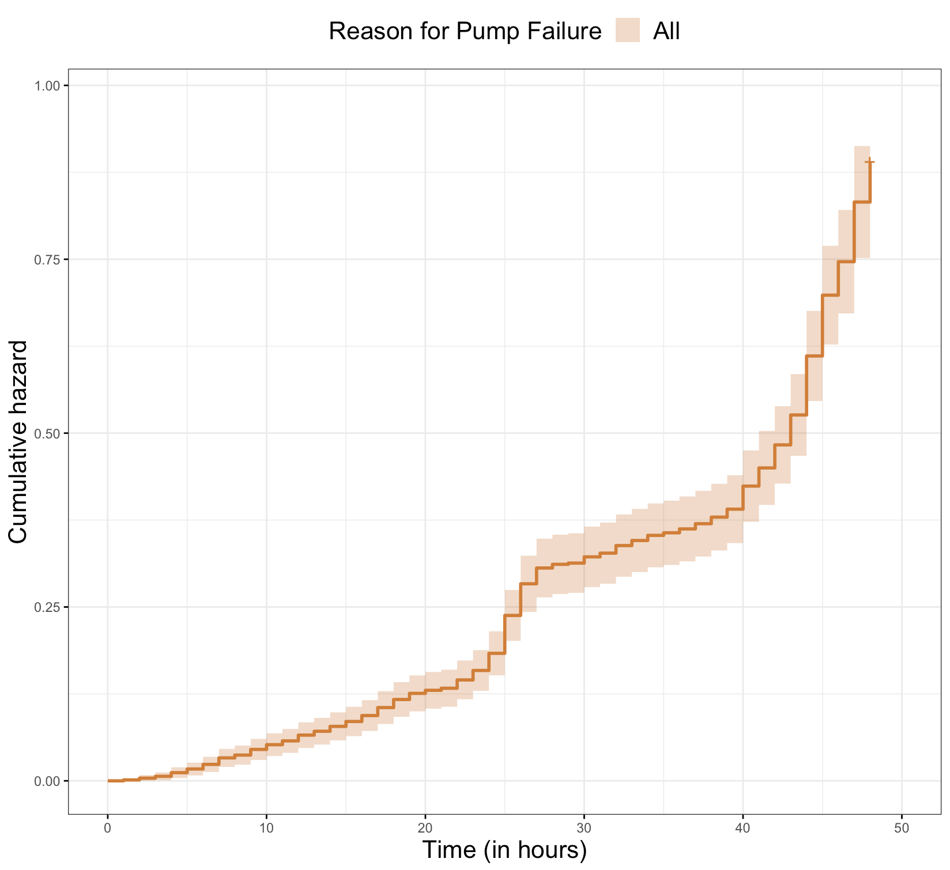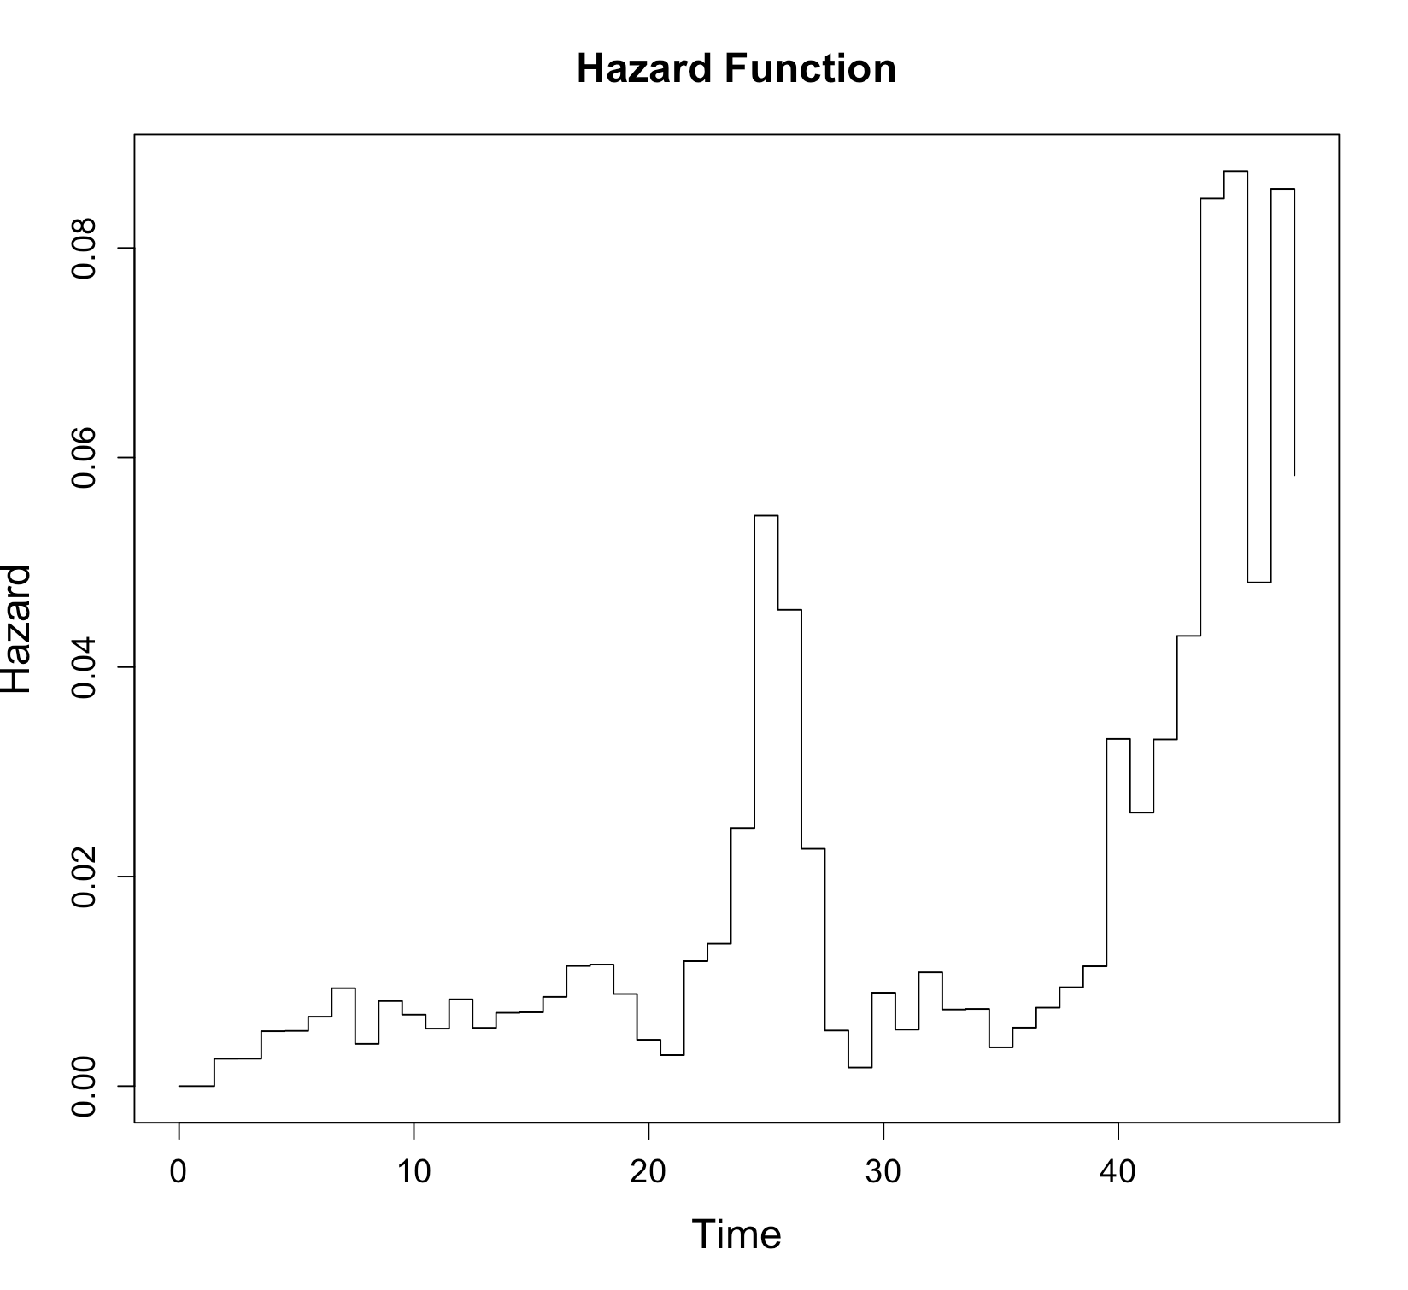The Hazard Function plot (Figure 3) below generated some important findings that can be explained by the Survival plot above. First, the high hazard (i.e. high risk of failure) between 24-26 hours. This is most likely due to the fact that Survival curve for Jammed experienced a sudden and continuous drop starting from 24 hours. Next, an even higher hazard between 45-48 hours. This can be explained by the huge increasing failures caused by Surge and Motor starting from 45 hours. These two peaks appear to be due to distinct events and those should be studied to determine the best way to protect the pumps from failure. The Cumulative Hazard plot (Figure 4) is just the total hazard up until 48 hours. As can be seen, the two peaks we observed in Figure 2 lead to a temporarily steeper slope at 24 hours and an even steeper slope at 45 hours.

Figure 3. Hazard Plot Figure 4. Cumulative Hazard Plot

**Conclusion**

Through our analysis we delivered summary statistics on the survival status of 770 pump stations within the critical 48-hour period, having an overall median survival time of 45 hours. Also, given the results showed above, all different reasons for pump failure had different median survival times and survival curves. Based on these results, our team recommends maintaining the information on the different types of failure separate considering they are statistically different.

In addition, we found two peaks in the hazards plots around the 25-hour and 45-hour marks. We hypothesized that two specific events led to the increased failure rates for jamming and surge- related failures. Also, the number of mechanical failures significantly increased around the 45-hour mark. We recommend investigation into what events caused these failures during Hurricane Katrina, and what steps can be taken to limit these during future hurricanes.